Draft Concept
World Entrepreneurs Investment Forum 2022: “Connecting Minds towards Achieving the SDGs through Entrepreneurship, Innovation and Investment Post COVID 19”
March 28 to 30, 2022 (HYBRID) / Dubai Expo, UAE

Background
The World Entrepreneurs Investment Forum (WEIF), through its secretariat at the UNIDO ITPO / AICEI Bahrain and various partners, has managed to position itself as a leading pavilion of knowledge on entrepreneurship, innovation and impactful investments.
Over the previous editions of the Forum in 2015, 2017 and 2019; WEIF has been able to achieve major milestones and become the main dedicated Entrepreneurs Investment Forum by the UN System. The main theme of WEIF “Achieving the SDGs through Entrepreneurship, Innovation and Investment” was a crucial factor in its success. As it focused on the Global Developmental Sustainable Agenda and the UNIDO mandate of inclusive and sustainable industrial development (ISID) by means of leveraging the power of the private sector through stimulating and unleashing youth economic prosperity.
Initiated by UNIDO ITPO Bahrain in 2015 WEIF has become an international forum aimed at (1) sharing international best practices and exchanging experiences on the means of developing an optimum conducive ecosystem that would unleash domestic investment towards leveraging foreign direct investment through entrepreneurship, innovation and impactful investments; (2) Creating linkages and business partnerships between entrepreneurs around the globe.
The Forum has been supported by a number of local, regional as well as international partners namely; line Ministries, governmental organizations, United Nations Agencies, NGOs, financial developmental institutions, regional and international organizations, commercial banks, universities, SME support institutions, research centers, think tanks, incubators, accelerator’s, chambers of commerce & industry and others.

WEIF in Figures
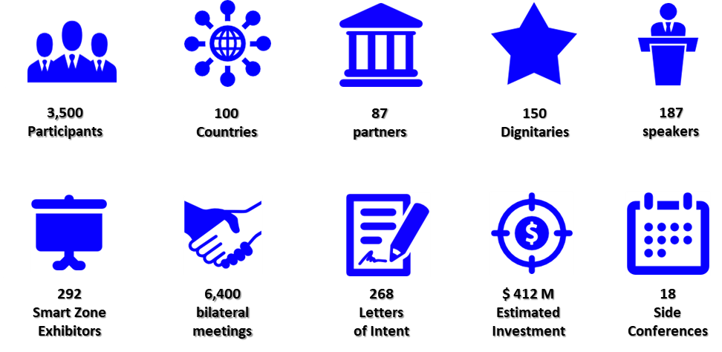

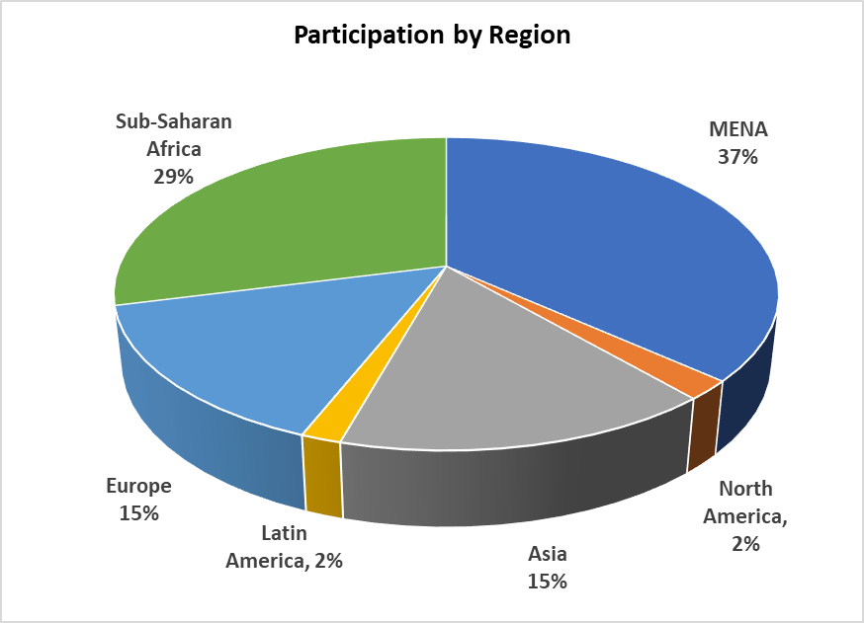

World Context
As the World is being faced by major new challenges brough about by the COVID 19 pandemic and its unprecedented ripple effects on the World Economy coupled with the need to act fast on addressing the SDGs; all within the backdrop of the swift digital transformations. All these pressures are creating more imbalances within the World and are deepening the economic and technological gap. Hence, it is unsurprising that entrepreneurs, start-ups and MSMEs are some of the most heavily impacted.
Although COVID 19 has presented major negative challenges, it has also played a positive role in inducing an accelerated technological transformation; and it is crucial to support MSMEs and entrepreneurs through facilitating their integration in the 4th industrial revolution. Many entrepreneurs where able to swiftly move into virtual platforms to ensure their business continuity and many are struggling to make ends meet.
Putting that into perspective, it is vital that decision makers and stakeholders ensure that the ecosystems in their countries swiftly adapt and embrace this transformation; in order to maintain sustainability and develop new tools that would enhance, boost and facilitate conducive ecosystems for unleashing entrepreneurship, investment both domestic and foreign, innovation and digitalization especially in the Arab Region and Africa; thus, leading to a more inclusive and sustainable future.
WEIF 2022
In line with the existing playing field that exists the World Entrepreneurs Investment Forum 2022 will focus on addressing what is needed to be done on the level of Government’s, multinational organizations and the private sector to achieve Entrepreneurial and Economic Resilience post COVID 19 in the Arab Region, Africa and the World.
Accordingly, WEIF will be organized by UNIDO ITPO / AICEI Bahrain under the banner of the League of Arab States at the Dubai Expo Pavilion in cooperation with the Union of Arab Chambers; the Arab Bank for Economic Development in Africa, and a number of regional and international partners.
Drawing on the Dubai Expo theme “Connecting Minds, Creating the Future”, which recognizes that generating sustainable solutions to global problems demands collaboration across cultures and regions whilst the subthemes of Opportunity, Mobility and Sustainability define the principal drivers of progress.
The WEIF will play a vital role in exposing the power of Entrepreneurs and Innovators in creating partnerships to secure a prosperous future and sustainable solutions for the globe challenges.

Main objectives
- Introducing international best practices aimed at developing conducive ecosystems for enhancing and advancing entrepreneurship, Investment both domestic and foreign, innovation and digitalization with special focus on the Arab Region and Africa; thus, leading to a more inclusive and sustainable future
- Facilitating business partnerships and investments for domestic enterprise creation and expansion,
- Highlighting best practices for governments and financial institutions towards entrepreneur’s resilience
- Creating a platform for entrepreneurs from around the globe to develop joint investments and trade facilitation.
- The COVID 19 pandemic and what needs to be done to ensure entrepreneurial - SME resilience and continuity; through stimulating impactful bankable investments that would support sustainability and growth in the Industrial sector
- COVID 19 has induced an accelerated technological transformation leading to a new normal; accordingly, it is crucial to support SMEs and entrepreneurs through facilitating their integration in the 4th industrial revolution

WEIF main themes
WEIF 2022 will address the main theme “Achieving the SDGs through Entrepreneurship, Innovation and Investment Post COVID 19” and will encompass a number of sessions; mainly,
- Ensuring and sustaining Entrepreneurial Resilience Post COVID 19
- Transforming Resilient Sustainable Financial Inclusion
- Developing conducive ecosystems for entrepreneurship and innovation / Digital Transformations
- Role of educational institutions, think tanks and research centers in unleashing entrepreneurship and innovation
- Reviving Trade and Heritage towards Sustainable Development
- Green Industry and Blue Growth
- SME Coalition for Africa
- Social entrepreneurship and corporate responsibility in the new reality
- Creative and Cultural Entrepreneurs

It is was also agreed that the Union of Arab Banks will organize a 4-hour symposium/workshop on financial inclusion in a digital economy. The event will bring about private banks and developmental funds in addressing tools, mechanisms and joint cooperation towards financial literacy and economic empowerment in Africa and the Arab Region.

WEIF Parallel Side Events
- Entrepreneur to Entrepreneur bilateral meetings
- 2nd Arab Entrepreneurs and Innovation Rally
- Joint Arab Chambers Week
- Special event led by the Union of Arab Banks “Digital Financial Sustainable Inclusion”
- Trade & Heritage
- Unleashing Creative Entrepreneurs
- Cultural Night
- Creative Workshops on Jewelry design, artisan, etc.

Expected Outcomes
- The Participation of 1000 participants physically and 10,000 virtually consisting of; dignitaries, philanthropists, experts, entrepreneurs, innovators, investors, academicians and others from across the globe with special focus the Arab Region, Africa and Asia;
- Participation of major developmental organizations and Funds; Chambers of Commerce, Industry and Agriculture; Economic associations and entrepreneur’s networks; Specialized entrepreneurship and MSME agencies; Universities and academicians; Major financial institutions and Technology providers and investors.
- The Forum aims to provide a platform for Entrepreneurs-to-Entrepreneurs bilateral meetings and matching with the aim of developing joint investments, collaboration and trade facilitation.
- Develop an action please towards achieving resilience and the SDGs by focusing entrepreneurship, innovation and investment
- Allow the participants to deliberate on the challenges, opportunities, threats, and the road forward towards achieving the SDGs and ISID in the back drop of the 4IR and COVID.

Main Organizers
The Union of Arab Chambers and under the League of Arab States pavilion in Dubai Expo 2020; will be partnering with UNIDO ITPO Bahrain, the Arab Bank for Economic Development in Africa, the Union of Arab Banks in organizing the World Entrepreneurs Investment Forum 2022.
Possible Sample Partners
- Arab ICT Union
- Islamic Development Bank
- International Peace Institute
- International SME Network (INSME)
- Fondazione Eni Enrico Mattei
- International Women Entrepreneurs Challenge
- Global Entrepreneurship Network
- Confederation of Indian Industries
- Shenzhen Federation of Youth Entrepreneurship Promotion
- Islamic Chamber of Commerce, Industry and Agriculture
- Creative Business Network
- Islamic Cooperation Youth Forum
- World Business Angels Investment Forum
- World Free Zones Organization
- Bahrain Chamber of Commerce and Industry
- Oqal Angel Investors

Forum Events:
- High-level session
- Panel Sessions
- Workshops
- Exhibition
- Bilateral Meetings
Event Dates & Venue:
March 28 to 30, 2022 / Dubai Expo, United Arab Emirates

